|  |  |
| --- | --- |
| Experiment Number:05 | **05** |
| **Title: Performing an Initial Router Configuration using cisco packet tracer.** |
| ▪ |  |

**Second Year Advanced Computer Networking**

**Theory:-**

**Topology**

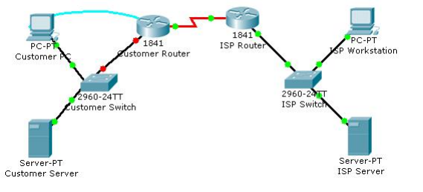

**Objectives**

* Configure the router host name.
* Configure passwords.
* Configure banner messages.
* Verify the router configuration.

**Background / Preparation**

In this activity, you will use the Cisco IOS CLI to apply an initial configuration to a router, including host

name, passwords, a message-of-the-day (MOTD) banner, and other basic settings.

Note: Some of the steps are not graded by Packet Tracer.

**Step 1: Configure the router host name.**

a. On Customer PC, use the terminal emulation software to connect to the console of the customer Cisco

1841 ISR.

Set the host name on the router to CustomerRouter by using these commands.

Router>enable

Router#configure terminal

Router(config)#hostname CustomerRouter

**Step 2: Configure the privileged mode and secret passwords.**

1. In global configuration mode, set the password to cisco.

CustomerRouter(config)#enable password cisco

Set an encrypted privileged password to cisco123 using the secret command.

CustomerRouter(config)#enable secret cisco123

**Step 3: Configure the console password.**

a. In global configuration mode, switch to line configuration mode to specify the console line.

CustomerRouter(config)#line console 0

Set the password to cisco123, require that the password be entered at login, and then exit line configuration mode.

CustomerRouter(config-line)#password cisco123

CustomerRouter(config-line)#login

CustomerRouter(config-line)#exit

CustomerRouter(config)#

**Step 4: Configure the vty password to allow Telnet access to the router.**

a. In global configuration mode, switch to line configuration mode to specify the vty

lines.

CustomerRouter(config)#line vty 0 4

Set the password to cisco123, require that the password be entered at login, exit line configuration mode, and then exit the configuration session.

CustomerRouter(config-line)#password cisco123

CustomerRouter(config-line)#login

CustomerRouter(config-line)#exit

CustomerRouter(config)#

**Step 5: Configure password encryption, a MOTD banner, and turn off domain server lookup.**

a. Currently, the line passwords and the enable password are shown in clear text when you show the running configuration. Verify this now by entering the show running-config command.

To avoid the security risk of someone looking over your shoulder and reading the passwords, encrypt all clear text passwords.

CustomerRouter(config)#service password-encryption

Use the show running-config command again to verify that the passwords are encrypted.

To provide a warning when someone attempts to log in to the router, configure a MOTD banner.

CustomerRouter(config)#banner motd $Authorized Access Only!$

Test the banner and passwords. Log out of the router by typing the exit command twice. The banner displays before the prompt for a password. Enter the password to log back into the router.

You may have noticed that when you enter a command incorrectly at the user or privileged EXEC prompt, the router pauses while trying to locate an IP address for the mistyped word you entered. For example, this output shows what happens when the enable command is mistyped.

CustomerRouter>emable

Translating "emable"...domain server (255.255.255.255)

To prevent this from happening, use the following command to stop all DNS lookups from the router CLI.

CustomerRouter(config)#no ip domain-lookup

Save the running configuration to the startup configuration.

CustomerRouter(config)#end

CustomerRouter#copy run start

**Step 6: Verify the configuration.**

a. Log out of your terminal session with the Cisco 1841 customer router.

b. Log in to the Cisco 1841 Customer Router. Enter the console password when prompted.

c. Navigate to privileged EXEC mode. Enter the privileged EXEC password when prompted.

d. Click the Check Results button at the bottom of this instruction window to check your work.

Reflection

Which Cisco IOS CLI commands did you use most?

How can you make the customer router passwords more secure?